Book Cross Product Spread Order

Overview

Current processing
- No cross product spread (CPS) order is booked.

New requirement
- After auction and trade processing, CPS order can be booked, per order’s handling instruction.

Implementation
- Currently, an empty CPS book is already created for each cross product, upon HybridTradeServer start/failover and intra-day new cross product creation.
- For booking CPS order, follow the following flow chart:
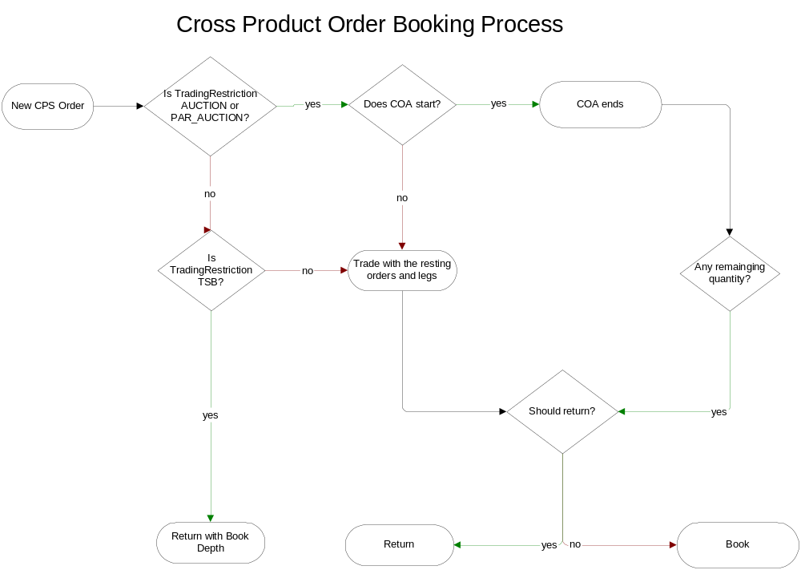
- Following is the detailed implementation for booking cross product order:
  - In BrokerProcessorSpreadHybridImpl.java, remove isBuyWrite checking from “private void postProcess()”:
// short term approach for cross product, the order with remaining quantity
// will be returned to PAR, not booked, this will be changed in the
// future release
if (reason < 0 && order.getRemainingQuantity() > 0 &&
orderBook.getTradingProduct().isBuyWrite()) {
reason = (order.getTradedQuantity()==0)
// Nothing done with the order:
? OrderRoutingReasons.NOT_TRADED_NOT_AUCTIONED
// Not really auctioned, but it's the best code we have that TPF will accept:
: OrderRoutingReasons.PARTIALLY_TRADED_AUCTIONED;
}
  - In BrokerProcessorSpreadHybridImpl.java, remove isBuyWrite checking from “private void postProcessAuctionOrder()”:
// cross product doesn't book the order for the current release
// so we'll bypass the processTradable logic for now
// it will be changed in the future release
if (!orderBook.getTradingProduct().isBuyWrite()) {
Side side = auction.getSide();
Price execPrice = order.getHandlingInstruction().getExecutionPrice();
if (side.isFirstBetter(execPrice, auction.getStartingPrice())) {
processTradable(order, orderBook, flipSignOnPrice(execPrice));
}
}
  - A new trading property enableBookingCPSOrder will be added to enable/disable booking the remainder of CPS order with TradingRestriction of Auction and Book. At the end of “private short getReturnCodeForOrder()” in BrokerProcessorSpreadHybridImpl.java, add the following logic:
if (!enableBookingCPSOrder && order.getTradingProduct().isBuyWrite() && (returnCode < 0))
{
short tradingRestriction = order.getHandlingInstruction().getTradingRestriction();
if (restriction == TradingRestrictions.AUCTION)
{
if (order.getTradedQuantity() == 0)
{
returnCode = OrderRoutingReasons.NOT_TRADED_AUCTIONED;
}
else
{
returnCode = OrderRoutingReasons.PARTIALLY_TRADED_AUCTIONED;
}
}
else if (restriction == TradingRestrictions.BOOK)
{
if (order.getTradedQuantity() == 0)
{
// need to find an appropriate return code for this scenario
}
else
{
returnCode = OrderRoutingReasons.PARTIALLY_TRADED;
}
}
}
- For trading incoming CPS order with the booked orders and legs:
  - In BrokerProcessorSpreadImpl.java, remove “protected boolean shouldTradeBookedSpread()”, and remove the shouldTradeBookedSpread checking from “protected void tradeBookedSpreads”:
if(!shouldTradeBookedSpreads(product))
{
return;
}
  - Move private int tradeCrossProductLegs(Order strategyOrder, …) from NTradeServiceImpl.java to TradeServiceImpl.java.
  - In tradeBookedSpreads()of BrokerProcessorSpreadImpl.java, it will call createTradeForBookedSpreadsWithLegs() of TradeServiceImpl.java to create cross product order with legs trade report. Changes need to be made in createTradeForBookedSpreadsWithLegs() of TradeServiceImpl.java for cross product orders so that it will call isDerivedQuoteWithinNTicksOfNBBO() and tradeCrossProductLegs(Order strategyOrder, …) to create cross product order with legs trade report, where assumption is made here that price time allocation strategy is applied to the cross product orders during trade with legs.
- Booked CPS orders will participate COA trade:
  - After reviewing the code, in createSpreadAuctionTrade(), booked orders are included in the COA trade for cross product, hence, no code change is needed.
- Upon HybridTradeServer failover, recover and book cross product orders:
  - Currently, the CPS orders are successfully retrieved from the database.
  - To book the retrieved CPS orders, remove the following code from OrderBookHomeImpl.java:
// if it's a cross product order, don't book the order, just
// return the order
if (book.getTradingProduct() != null &&
book.getTradingProduct().isTradableCrossProduct()) {
order.changeToState(InternalOrderStates.ROUTED_AWAY);
order.returnedWithReason(OrderRoutingReasons.ORDER_REJECTED);
return;
}
- Changes need to be made on OHServer side so that CPS orders can be routed to TE for the followingTradingRestriction, in addition to the current TradingRestriction AUCTION:
const order::TradingRestriction AUCTION = 1001;
const order::TradingRestriction BOOK = 1002;
const order::TradingRestriction AUTO_EX = 1003;
const order::TradingRestriction PAR_AUCTION = 1004;
const order::TradingRestriction TOP_SPREAD_BOOK = 1005;
const order::TradingRestriction PAR_TRADE_ALL = 1006;
Following is the list of OHS files that have isCrossProductTradable() checking, which should be reviewed and removed:
  - /vobs/dte/ohs/integration/impls/com/cboe/ohs/workflow/steps/WFStepCrossProductChecker.java
  - /vobs/dte/ohs/integration/impls/com/cboe/ohs/workflow/steps/WFStepIsCOAReject.java
  - /vobs/dte/ohs/integration/impls/com/cboe/ohs/workflow/steps/WFStepMultiLevelDeviationCheck.java
  - /vobs/dte/ohs/integration/impls/com/cboe/ohs/workflow/steps/WFStepMultiLevelDeviationCheckOMTBook.java
  - /vobs/dte/ohs/integration/impls/com/cboe/ohs/workflow/steps/WFStepMultiLevelDeviationCheckPARBook.java
  - /vobs/dte/ohs/integration/impls/com/cboe/ohs/workflow/steps/WFStepSetHandlingInstructionsForExpressOrder.java
  - /vobs/dte/ohs/integration/impls/com/cboe/ohs/workflow/steps/WFStepUpdateToORD.java
  - /vobs/dte/ohs/integration/impls/com/cboe/ohs/workflow/steps/electronic/WFStepElectronicSetHandlingInstructionsForExpressOrder.java

Scripts
- None

Database
- None

SetContext
- None

XML/DTD
- None

Trading Property
- None

Homes/Services
- None

ImplPlan
- None

PerformanceTestingProcedure
- None

TestingProcedure
- None

OperatorProcedure
- None

Fallback/Failover
- None

